SESSION 8 — Gearhaven
Beat 7 — Sphere Upgrade + “Where Do You Go?”

The Sphere Charges
You’re still standing in the quiet beneath the sleeping giant when it happens. The air all around you is full of drifting light — motes, hundreds of them, the freed planar energy shaken loose when the corruption broke, floating up out of the rubble like fireflies rising after rain.
And Lilly’s Sphere is drinking them in.
One by one the motes drift toward the glowing orb in her hands and sink into it, and with every one, the Sphere shines brighter. You remember what Vane said, all the way back in his workshop — that the Sphere was a gatherer, built to catch planar energy and hold it. It was never broken. It was just starving. And now, with the great corruption gone and the air thick with freed light, it is finally, finally drinking its fill.
The little electric-yellow heartbeat inside pulses faster. Stronger. Brighter.
▶ How the Sphere charges. Direct cause-and-effect: the boss’s death freed a bloom of motes, and the Sphere (established as a gatherer in Beat 3) drinks them. The corruption was starving it; now it feeds. Let Lilly’s player watch it happen.
Lilly (breathless): “It’s eating the light. All of it. I’ve never seen it this bright — it’s like it’s been hungry this whole time and nobody knew.”

Pikachu’s Projection
The Sphere flares — bright enough that you all shield your eyes — and then, hovering in the air just above Lilly’s hands, a shape unfolds out of the light.
It’s small. Four-legged. Two long ears, a lightning-bolt tail, two bright black eyes. It’s made of glowing golden energy, not quite solid — you can see the rubble through it — but it’s here, and it’s looking right at Lilly, and its little face does something that can only be called a smile.
“Pikachu,” Lilly whispers, tears starting. “You’re— you’re really in there.”
And then Ursa feels it: his Mark of Handling, still wide open from soothing the giant, reaches — and catches something. A voice. Not in words. In feelings, and pictures, pouring straight into his head the way the Custodian’s did. Pikachu is speaking, and Ursa is the only one who can hear.
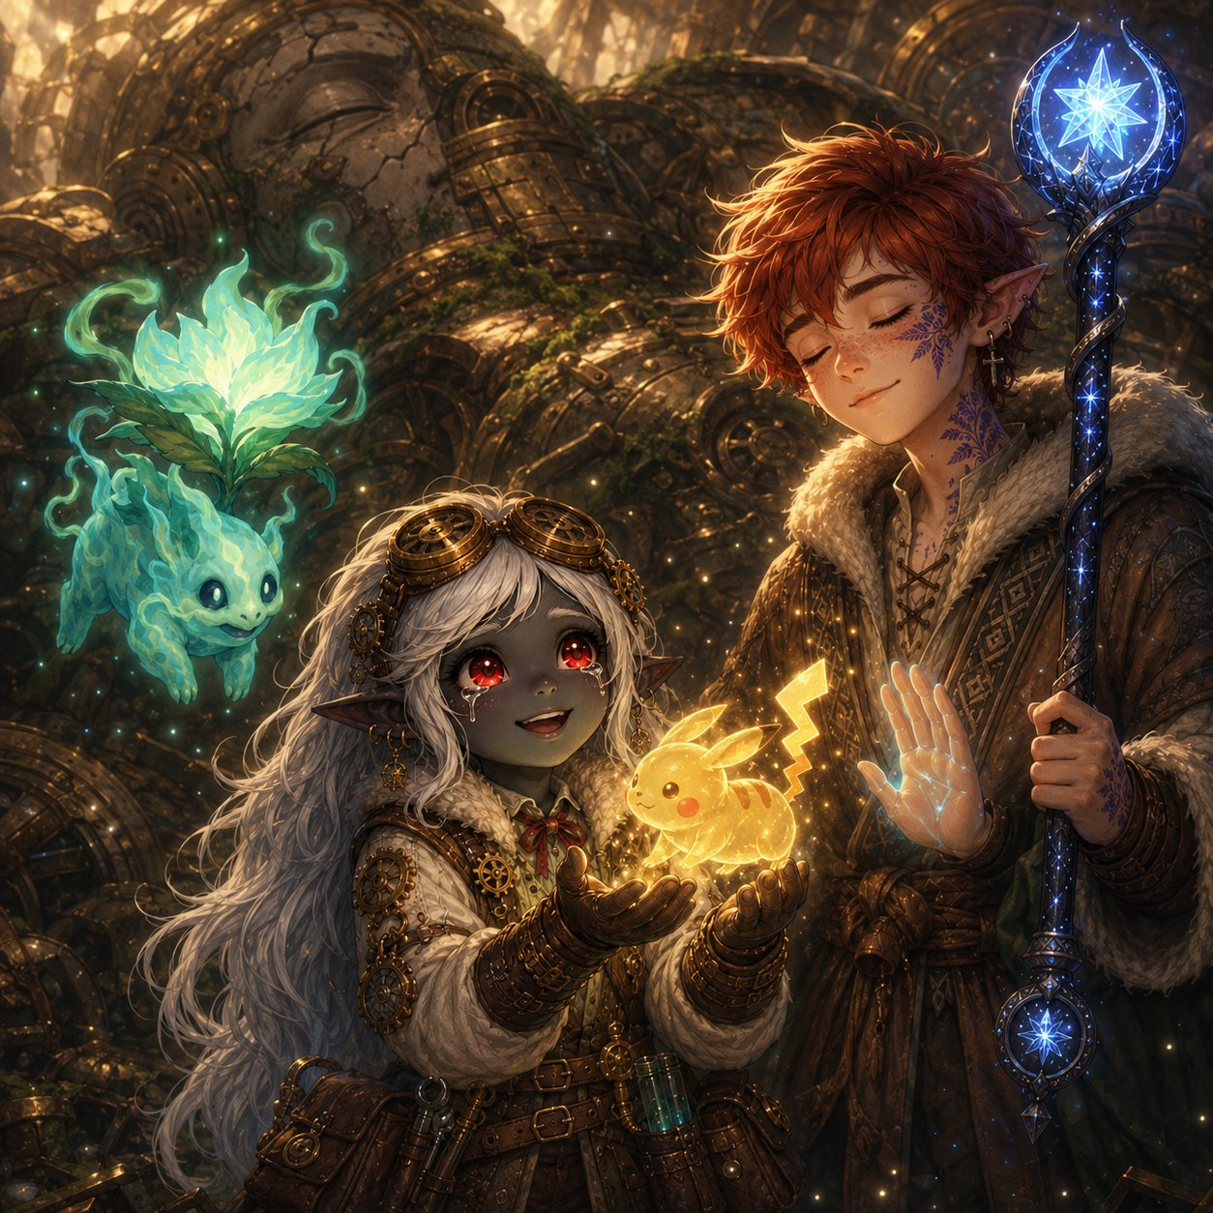
Pikachu’s projection — and Ursa’s Mark of Handling lets him hear what the others cannot.
▶ Ursa’s Mark, second payoff in two beats. The same gift that soothed the Custodian now lets him commune with Pikachu — reinforcing the mystery that his Mark reaches things it shouldn’t. Let Ursa be the translator; this makes the Pikachu moment a party scene, not just Lilly’s. Read the warning below as Ursa relaying what he feels.
Ursa closes his eyes and listens, and haltingly tells you what comes through:
“It says… thank you. For freeing it, even a little. It says it can’t stay — not yet — it needs more than this to come back all the way. But it wanted you to know something. A warning.”
“There’s something out there. Something… vast. And hungry. It’s been pressing on the walls of every world, reaching in through the cracks — and the rot we’ve been fighting, the corruption, it all comes from that. From the hunger outside.”
“And it’s not alone. Pikachu shows me… a shadow. Something that goes ahead of the hunger, whispering, pulling the worlds apart from the inside. A servant. A herald.”
Ursa’s eyes open, wide. “And it says— Pikachu says it’s part of this. Somehow. That Lilly’s mother knew. That it’s not just a lost friend — it’s a key. To something. But it can’t tell us more until it comes back all the way.”
The golden shape leans forward, presses its glowing forehead gently to Lilly’s, and then — softly, like a candle in the wind — flickers out, back into the Sphere. But the Sphere keeps glowing, warm and bright, in a way it never did before.
▶ The cosmic warning (no names). Pikachu names the stakes in dread-images: a vast hunger (Maldrith — unnamed), a herald-shadow (Nyxthid — unnamed), and that Pikachu is a key its mother understood. Keep the names out of its “mouth” — it speaks in feelings. This deepens Pikachu from lost-pet to mysterious key, reframes the corruption as something reaching in from outside, and seeds the big bad + herald without revealing them. Save the names for the Shadow Rift later.
Lilly (wiping her eyes): “A key. My mom gave me a key and never told me. …Of course she did.”
Stabby: “Okay, that was beautiful, and ALSO terrifying. A big hungry thing outside the world? With a creepy shadow helper? …Why does that sound like my idol’s been trying to tell me the same thing?”
Ursa (shaken): “I keep hearing things I shouldn’t be able to hear. The giant. Now this. My Mark’s changing. …Or I am.”

Rest & Return to the Guild
You are bone-tired. Whatever comes next can wait until you’ve slept and eaten and stopped shaking. So you rest.
And when you climb back up through Gearhaven the next morning, the city is… different. The corruption is gone. The trams run again. The Great Governor beats slow and steady under your feet, Boom… Boom… Boom, calm as a sleeping heart. And the people — the people are out, in the streets, blinking in the sun like they survived a long storm. And word has spread about three young heroes and a glowing fey, because as you walk, people stop. And stare. And then, quietly, they begin to clap.
By the time you reach the top of Cogtooth Hill, half the city is walking behind you. Vane is waiting at the Guild doors, and he is beaming.
Stabby (loving it): “Are they clapping for US? They’re clapping for us. Lilly, they’re CLAPPING. I’m gonna cry. Don’t tell anyone I said that.”

Vane Explains the Plan
Vane sweeps you inside, sits you down, presses warm food into your hands, and for once in his life holds still long enough to explain.
“You did it. You understand that, don’t you? When you freed the Custodian — the cracks closed. All of them. The rifts under the city, the surge in the plaza, every tear that’s been bleeding that poison into Gearhaven — gone. Sealed. The moment the guardian was free.”
“That’s the answer. That’s the whole answer I’ve been chasing for ten years. The rifts can’t be closed from our side — I tried, believe me. But every fraying world has a heart. A guardian, like your Custodian — some great old thing the corruption sinks into first. And when you free that guardian… the cracks in that world close on their own. You proved it. Last night. You proved the thing can be done.”
“So here is what we do. My portal — my folly, my ten-year door — with that Sphere of yours as its anchor, I can finish it. I need time. A year, near enough. And when it’s ready, it will carry you through — to the broken planes, one by one. You find each world’s corrupted guardian. You free it, the way you freed the Custodian. And one by one, you close the cracks from the far side, before that hunger your little friend warned about can pour all the way in.”
He looks at the three of you, suddenly gentle. “But that’s a year away. The portal isn’t ready, and you three are children who’ve just saved a city and earned a rest. So I’m not going to ask you to sit in my workshop and wait. I want you to go. Each of you has something pulling at you — I’ve seen it in your faces all week. Go answer it. Get stronger. Find what you need to find. And come back to me in one year, when the door is ready… and we’ll go save the worlds together.”
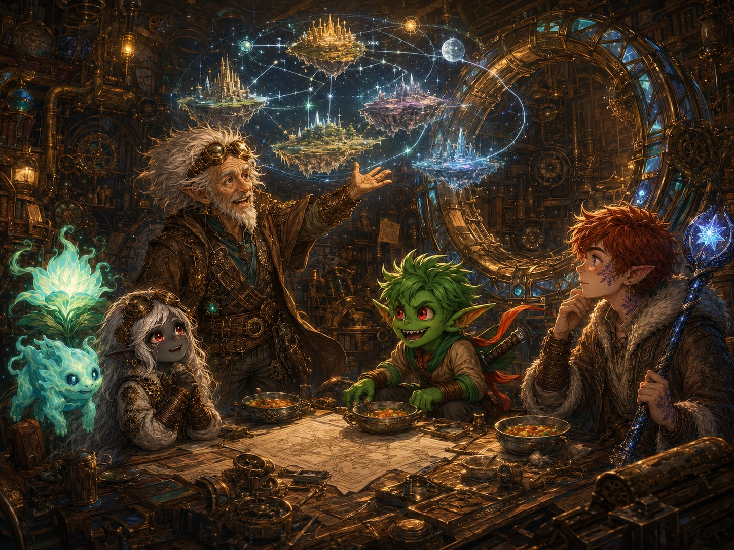
Vane lays out the plan — free each world’s corrupted guardian, and the rifts close from the far side.
▶ The mechanical exposition, all here. Vane answers everything: freeing the Custodian closed Gearhaven’s rifts (proof of concept); the go-forward is travel the planes, free each corrupted guardian, close each rift from the far side; the portal needs a year; and that year is the in-fiction reason the party splits up. The guardians are victims like the Custodian — every future boss is a tragedy to be undone, not a monster to be slain. This is the campaign’s engine, born from this session’s boss.
Lilly: “A year to build the greatest machine in the world. …You’re going to need help with that, you know.” (Vane: “I was hoping you’d say that.”)
Ursa: “Travel to other worlds. Free things like the Custodian. …I think that’s exactly what I’m for.”
Stabby: “A WHOLE year off to go do whatever I want and THEN I get to punch my way through magic worlds? Best. Plan. Ever.”

“Where Do You Go?” — The Send-Off
So it’s settled. One year. And then back here, to the Guild, when Vane’s door is ready.
But a year is a long time. And as you sit there, full and warm and safe for the first time in days, each of you feels it — a tug. A direction. Something you’ve been carrying all this time that’s finally asking to be answered. Where do you go?
▶ The send-off. Present each kid their three doors as in-character pulls, each with a hint of the reward (not full details). Let each kid choose one — that’s their solo year. (If your table wants to decide between sessions, present all three and let the pick happen later; it works either way.) Every door below was seeded across Beats 1–6, so the choices land as earned. Note their picks — you’ll open the next arc on the reunion, with each kid returning at level 7 changed by the road they chose.
🔵 Lilly’s Doors
Door 1 — Glimmerspire. Go home to the deep-gnome academy where your mother trained, and become the master artificer she was. (Tease: you’d come back with skills and secrets of artifice no one up here has seen in a hundred years.)
Door 2 — Stay & Build with Vane. Stay at the Guild and help finish the Rift Portal — and unlock the Sphere. (Tease: you’d come back having helped build the very door that saves the worlds — and maybe knowing what your Sphere truly is.)
Door 3 — Chase the Sphere’s Mystery. Follow the Sphere and Pikachu — find out what your mother really gave you, and what a “key” unlocks. (Tease: you’d come back with answers about Pikachu, your mother, and the part you’re meant to play.)
🔴 Stabby’s Doors
Door 1 — The Bloodfang. Go home to Bloodthorn Hollow. The clan is scared and splintering, and Skitch begged you to come. They need what you know. (Tease: you’d come back having maybe saved your whole clan — and stopped a war before it starts.)
Door 2 — Finish Your Training. Find a monastery and learn the rest of what Master Kaelon started — the stillness you found in the giant’s lightning. (Tease: you’d come back able to do things with that calm your body can barely dream of now.)
Door 3 — The Idol. Chase the mystery of the idol — what it is, why it goes cold near the corruption, why the blue light is afraid of it. (Tease: you’d come back knowing what you’ve been carrying all along — and it might be bigger than any of you guessed.)
🟣 Ursa’s Doors
Door 1 — Your Father’s Trail. Follow Ash east, to the old shrine in his logbook, and finally learn what happened to him. (Tease: you’d come back knowing your father’s fate — and maybe walking beside it.)
Door 2 — The Circle of Stars. Return to your Circle and deepen your bond with the constellations and the cosmic balance you’re tied to. (Tease: you’d come back wielding starlight in ways you can’t yet imagine.)
Door 3 — The Living World & the Mark. Follow the pull of your Mark — out into the wild, to understand why it reaches for things it shouldn’t, why you can hear the suffering of corrupted souls. (Tease: you’d come back understanding your gift — and your strange new place between the living and the lost.)

The Goodbye
And so, the next morning, at the edge of Gearhaven where three roads split toward three different horizons, it’s time.
You’ve never been apart. Not since the Gilded Acorn tavern, not for a single day. You’ve faced mad machines and planar rifts and a city-sized giant together. And now you’re going to spend a whole year apart, chasing three different callings, becoming three different, stronger people. Nobody quite knows what to say.
So Stabby says it. “Okay, this is dumb, I’m not gonna cry, YOU’RE gonna cry—” and then he just grabs both of them, and pulls them in, and the three of you stand there at the crossroads in one fierce tangled hug, holding on a little too long. Ghostbloom curls its warm teal glow around all three of you at once.
“One year,” Lilly says, muffled, into the hug. “Back at the Guild. The day the door opens.” “One year,” Ursa promises. “One year,” Stabby says. “And then we go save EVERYTHING. Try not to get cooler than me. Impossible, but try.”
And then you let go. Ghostbloom drifts back toward the Guild — it’ll wait with Vane, close to the Sphere and the door, until you all return. And the three of you turn toward your three roads… and walk.
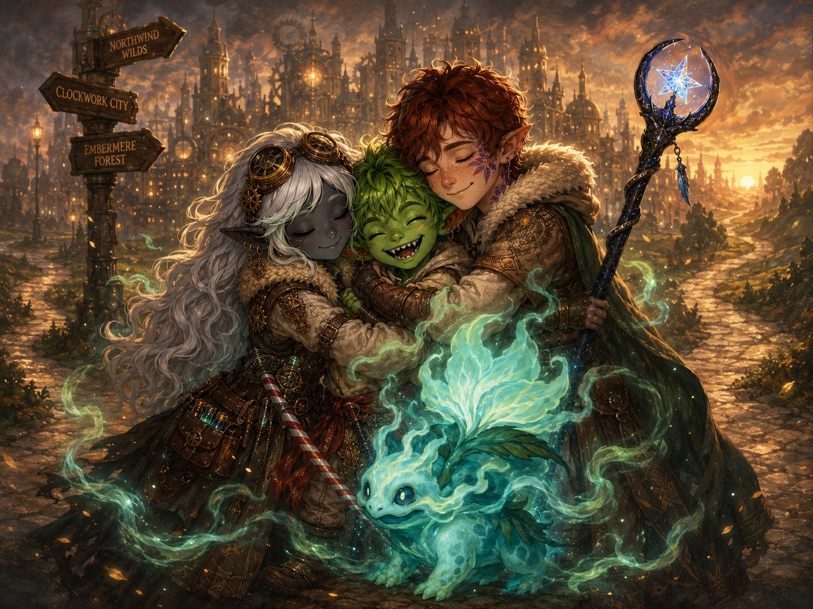
One fierce tangled hug at the crossroads — three roads, three callings, one year apart.
▶ The goodbye. Warm and hopeful with a bittersweet undertone, and Stabby’s joke to keep it from getting too heavy. Ghostbloom stays with Vane at the Guild (drawn to the Sphere/portal, a natural hub for the reunion). Let the kids have this moment — it’s the first time their characters part, and it makes the level-7 reunion mean something.

One Year Later
The Great Governor beats under Gearhaven, slow and steady, through a turning year.
Summer. Then the leaves go gold. Then snow on the brass rooftops. Then green again, and flowers in the Verdant Plaza, blooming over the place where a giant sleeps.
In a workshop at the top of Cogtooth Hill, a great ring of brass and crystal is taking shape, gear by gear, and an old man and a glowing fey work on it through every season, looking up at the door each time it opens — not yet, not yet — and waiting.
Far away, in a deep-gnome city, in a mountain monastery, on a road east toward an old shrine — three children who aren’t quite so little anymore are growing into who they’re going to be.
And the day is coming — soon now — when three roads will lead back to one door. And the Guardians of Elaria, together again and stronger than ever, will step through it, and go to save the worlds.
🌙 ONE YEAR LATER…
The party returns at level 7 — to be continued.
End of Beat 7 — and the end of Session 8. Hard cut. The reunion at the Guild (portal complete, party at level 7) is your next-session opener. Each kid returns changed by the door they chose — let their solo year inform who they are now, and what they gained.

